Hospitality and Tourism

Guest Recovery

Mr. Bodenburg

Guest Advocacy:

* For Guest recovery to be successful it must be quickly:

3 types of Outcomes

Lose/Lose

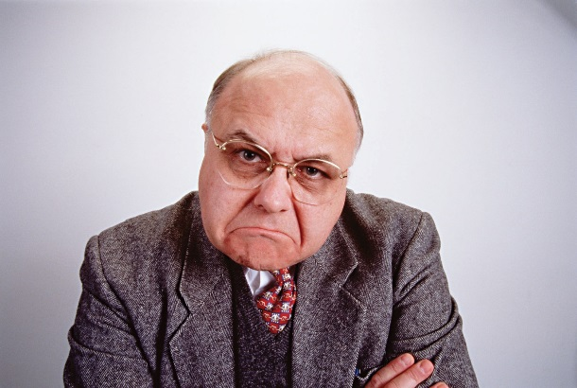



Win/Win

Lose/Win



**Make it Right:**

**L**

**A**

**T**

**E**